- Install Wireshark on your laptop, start a capture on your main network interface, and visit any website (like instagram.com). Stop the capture and note down the protocol names you see in the packet list.
ANS:
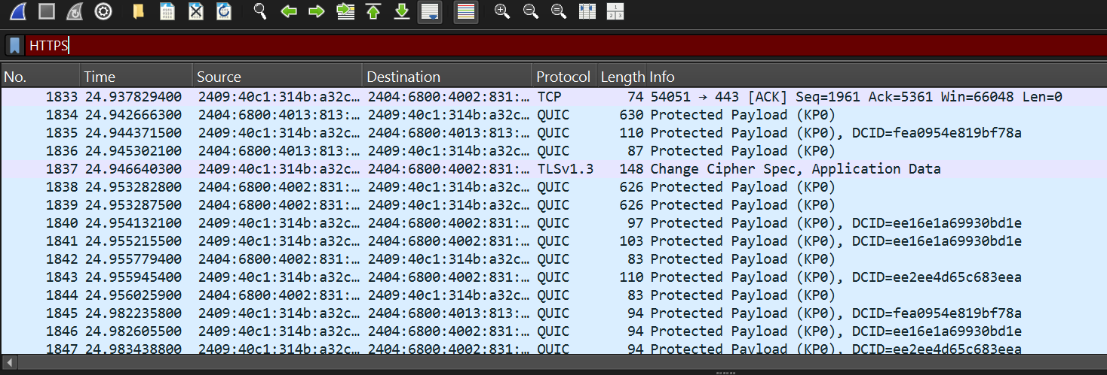
- Pick any 3 packets from your Wireshark capture and identify which OSI layer each packet mainly represents (for example, HTTP for Application layer, TCP for Transport layer, etc.).<br><br><em><strong>Hint:</strong> Use the Protocol column and Info details in Wireshark to help you map protocols to OSI layers.</em>
ANS:
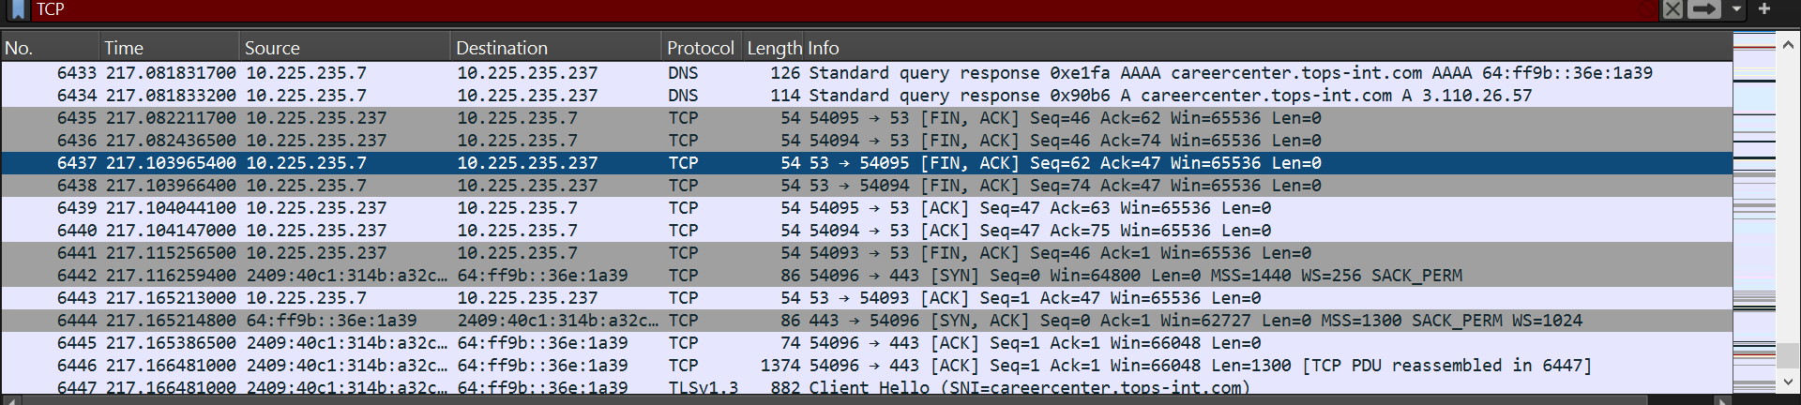
- Create a colorful diagram of the OSI Model using any drawing tool (MS Paint, Canva, or even paper and upload a photo). For each layer, add a real-world example from apps you use daily (e.g., WhatsApp uses the Application layer, Instagram images use the Presentation layer, etc.).
ANS:
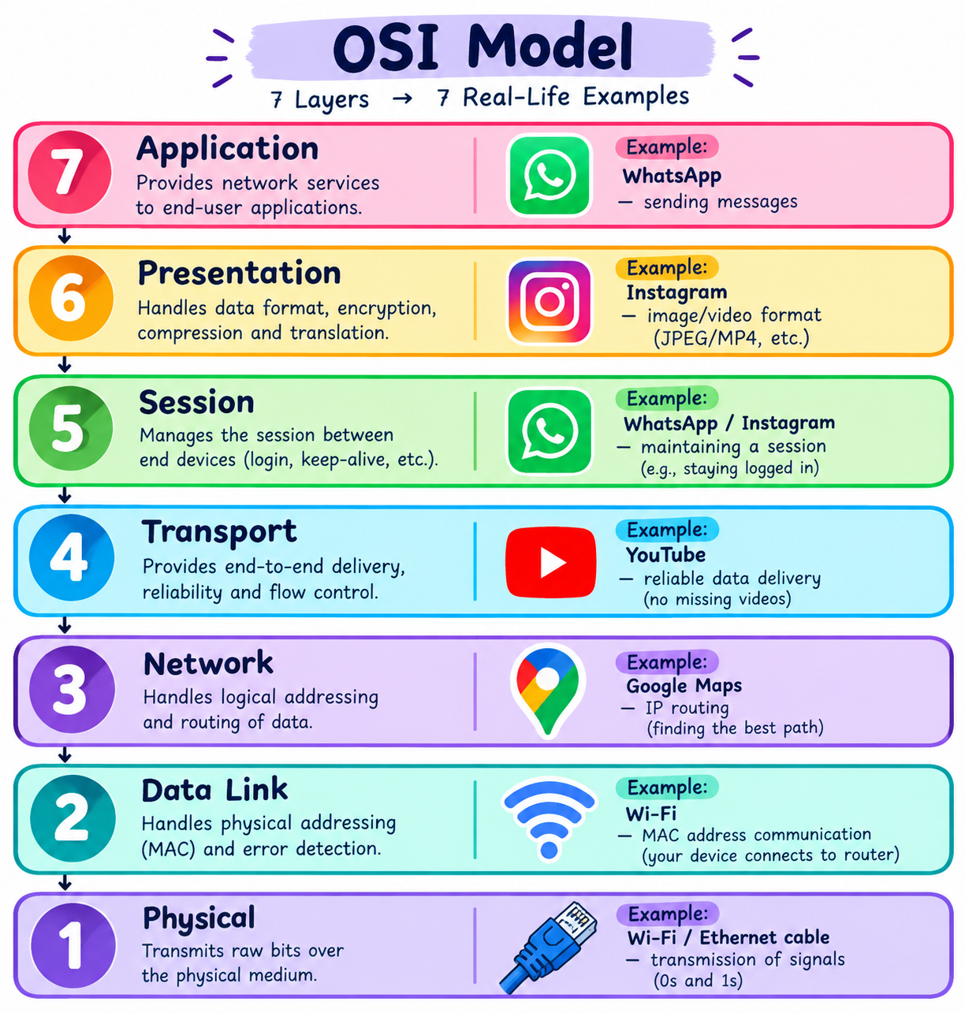
- Explain how sending a message on WhatsApp travels through at least 4 layers of the OSI Model, describing what happens at each layer in your own words.<br><br><em><strong>Hint:</strong> Think about how your message is typed, packaged, sent over the internet, and received.</em>
ANS:
Whatsapp:
- Application Layer: I type my message in WhatsApp and press the Send button.
- Transport Layer: The message is divided into smaller packets and prepared for reliable delivery.
- Network Layer: The packets use IP addresses, and routers find a path to the receiver.
- Physical Layer: The data is converted into signals and sent through Wi-Fi or mobile data.

